Implementation Notes: the Post a Listing Form layout like the homepage and search page but it mainly focused on gain information from the possible sellers with minimal distractions. Most changes are made in then <main> segment with additions to the CSS file while <nav>, <header>, <aside>, <footer> stayed the same.
For example, the listing type and property type follows the same format where you have limited options to select from to prevent wrong information from being inputted for the listing by the <select> only allows selection of the <options>
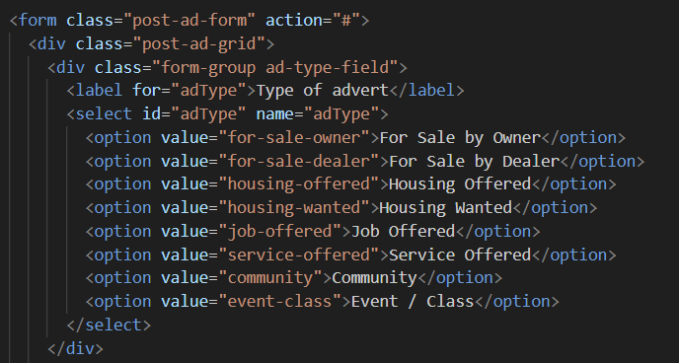
Any input that is need user input is set to <input type=text> for any manual inputs from the poster such as: firstname, surname , description ad title and price
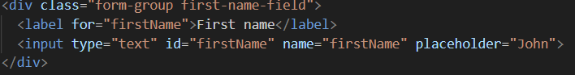
For the upload photo function there is a blank empty photo icon that makes it intuitive to interact with the image to upload the photo which had the “file uploader” input function
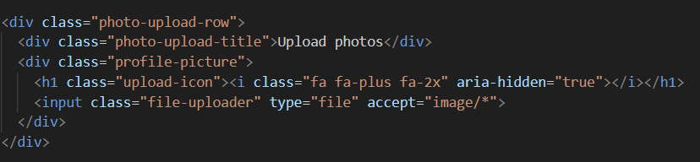
The website already saves the inputted data so the btn-secondary is mostly for placebo effect and the btn-primary actually submits the ad with the type=“submit”
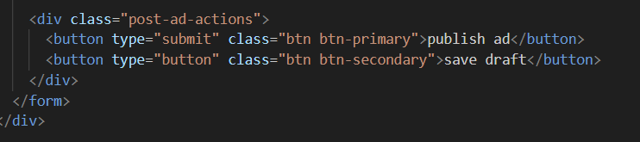
CSS for the Upload background image which controls the size and shadow of the bottom of the image to prevent it from blending into the pages white base background
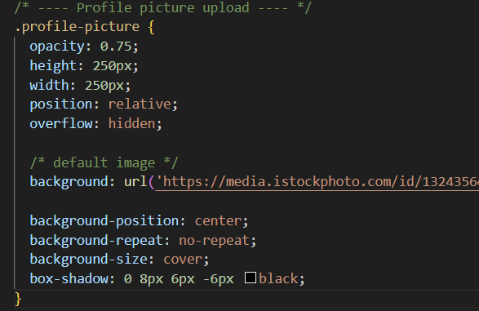
The CSS for the boxes and how much the fill the page
